Cassandra manual

What is Apache Cassandra?
Apache Cassandra is an open source, distributed and decentralized/distributed storage system (database), for managing very large amounts of structured data spread out across the world. It provides highly available service with no single point of failure.
Listed below are some of the notable points of Apache Cassandra:
- It is scalable, fault-tolerant, and consistent.
- It is a column-oriented database.
- Its distribution design is based on Amazon’s Dynamo and its data model on Google’s Bigtable.
- Created at Facebook, it differs sharply from relational database management systems.
- Cassandra implements a Dynamo-style replication model with no single point of failure, but adds a more powerful “column family” data model.
- Cassandra is being used by some of the biggest companies such as Facebook, Twitter, Cisco, Rackspace, ebay, Twitter, Netflix, and more.

History of Cassandra
- Cassandra was developed at Facebook for inbox search.
- It was open-sourced by Facebook in July 2008.
- Cassandra was accepted into Apache Incubator in March 2009.
- It was made an Apache top-level project since February 2010.
Features of Cassandra

(i) Peer to Peer Network

Cassandra is designed to distribute and manage large data loads across multiple nodes in a cluster.

Does not have Master Slave architecture( no SOP)

A node in Cassandra is structurally identical to any other node.

In case any node fails, it definitely impacts the throughput.

However incase of graceful degradation where everything does not come crashing at any given instant owing to node failure

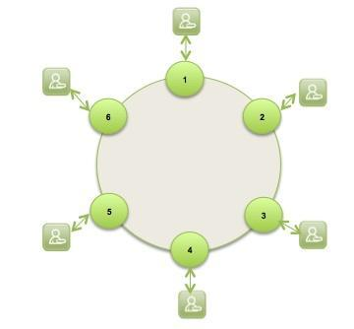

(ii) Gossip Protocol and Failure Detection
Gossip protocol is used for intra ring communication.

It is a peer to peer communication protocol which eases discovery and sharing of location and state information with other nodes in cluster.

Network Communication protocols inspired for real life rumour spreading.

Example – Node A wish to search for pattern in data
Round 1 – Node A searches locally and then gossips with node B.
Round 2 – Node A,B gossips with C and D.
Round 3 – Nodes A,B,C and D gossips with 4 other nodes ……

Round by round doubling makes protocol very robust.

(iii)Failure Detection- Anti-Entropy and Read Repair
For repairing unread data, Cassandra uses what’s called an anti-entropy version of the gossip protocol.
Anti-entropy and Read Repair

A cluster is made of several nodes.
To achieve fault tolerance, a given piece of data is replicated on one or more nodes.
A client can connect to any node in the cluster to read data.
AntiEntropy means comparing all the replicas of each piece of data that exist (or are supposed to) and updating each replica to the newest version.

Some times few nodes may respond with out –of date value . This can be repaired using Read Repair operation.

Read repair operation is performed either before or after returning the value to the client as per the specified consistency level.
(iv) Partitioner
A partitioner takes a call on how to distribute data on the various nodes in cluster. Nodes are logically structured in Ring Topology.
It also determines a node on which to place the very first copy of the data.

Basically a Partitioner is a hash function to compute the token of the partition key.

(v) Replication

Replication Factor(RF) determines the number of copies of data.

RF should ideally be more than one and not more than the number of nodes in the cluster.

Two replication strategies are,
Simple strategy
Network Topology strategy

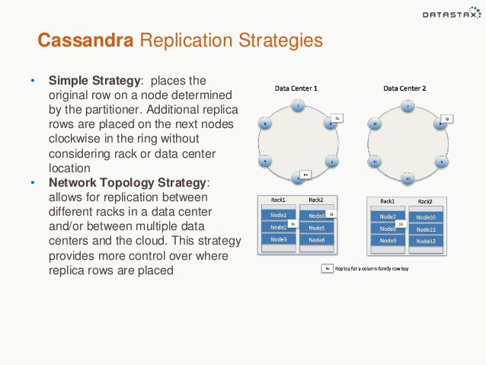

(vi) Writes in Cassandra

A client that initiates a write request.

It is first written to the commit log. A write is taken as successful only if it is written to the commit log.
The next step is to push the write to a memory resident data structure called Memtable. A threshold value is defined in the Memtable.
When the number of objects stored in the Memtable reaches a threshold, the contents of Memtable are flushed to the disk in a file called SSTable (Stored string Table). Flushing is a non-blocking operation.

It is possible to have multiple Memtables for a single column family.
One out of them is current and the rest are waiting to be flushed.

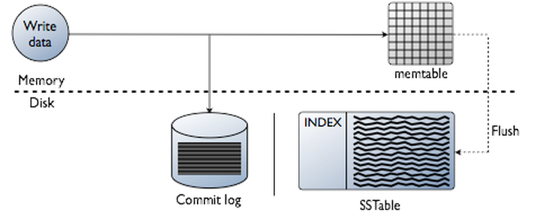

(vii) Hinted Handoffs

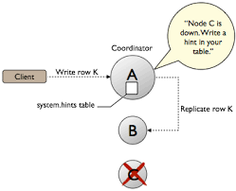

(viii)Tunable Consistency
Consistency describes how and whether a system is left in a consistent state after an operation.

In distributed data systems like Cassandra, this usually means that once a writer has written, all readers will see that write.

On the contrary to the strong consistency used in most relational databases (ACID ) Cassandra is at the other end of the spectrum (BASE for Basically Available Soft-state Eventual consistency).

Cassandra weak consistency comes in the form of eventual consistency which means the database eventually reaches a consistent state.

As the data is replicated, the latest version of something is sitting on some node in the cluster, but older versions are still out there on other nodes, but eventually all nodes will see the latest version.

Read Consistency Levels
Level | Description | Usage
ALL | Returns the record after all replicas have responded. The read operation will fail if a replica does not respond. | Provides the highest consistency of all levels and the lowest availability of all levels.
EACH_QUORUM | Not supported for reads. | Not supported for reads.
QUORUM | Returns the record after a quorum of replicas has responded from any data center. | Ensures strong consistency if you can tolerate some level of failure.
LOCAL_QUORUM | Returns the record after a quorum of replicas in the current data center as the coordinator has reported. Avoids latency of inter-data center communication. | Used in multiple data center clusters with a rack-aware replica placement strategy ( NetworkTopologyStrategy) and a properly configured snitch. Fails when using SimpleStrategy.
ONE | Returns a response from the closest replica, as determined by the snitch. By default, a read repair runs in the background to make the other replicas consistent. | Provides the highest availability of all the levels if you can tolerate a comparatively high probability of stale data being read. The replicas contacted for reads may not always have the most recent write.
TWO | Returns the most recent data from two of the closest replicas. | Similar to ONE.
THREE | Returns the most recent data from three of the closest replicas. | Similar to TWO.
LOCAL_ONE | Returns a response from the closest replica in the local data center. | Same usage as described in the table about write consistency levels.
SERIAL | Allows reading the current (and possibly uncommitted) state of data without proposing a new addition or update. If a SERIAL read finds an uncommitted transaction in progress, it will commit the transaction as part of the read. Similar to QUORUM. | To read the latest value of a column after a user has invoked a lightweight transaction to write to the column, use SERIAL. Cassandra then checks the inflight lightweight transaction for updates and, if found, returns the latest data.
LOCAL_SERIAL | Same as SERIAL, but confined to the data center. Similar to LOCAL_QUORUM. | Used to achieve linearizable consistency for lightweight transactions.

Write Consistency Levels
Level | Description | Usage
ALL | A write must be written to the commit log and memtable on all replica nodes in the cluster for that partition key. | Provides the highest consistency and the lowest availability of any other level.
EACH_QUORUM | Strong consistency. A write must be written to the commit log and memtable on a quorum of replica nodes in all data center. | Used in multiple data center clusters to strictly maintain consistency at the same level in each data center. For example, choose this level if you want a read to fail when a data center is down and the QUORUM cannot be reached on that data center.
QUORUM | A write must be written to the commit log and memtable on a quorum of replica nodes. | Provides strong consistency if you can tolerate some level of failure.
LOCAL_QUORUM | Strong consistency. A write must be written to the commit log and memtable on a quorum of replica nodes in the same data center as thecoordinator node. Avoids latency of inter-data center communication. | Used in multiple data center clusters with a rack-aware replica placement strategy, such as NetworkTopologyStrategy, and a properly configured snitch. Use to maintain consistency locally (within the single data center). Can be used with SimpleStrategy.
ONE | A write must be written to the commit log and memtable of at least one replica node. | Satisfies the needs of most users because consistency requirements are not stringent.
TWO | A write must be written to the commit log and memtable of at least two replica nodes. | Similar to ONE.
THREE | A write must be written to the commit log and memtable of at least three replica nodes. | Similar to TWO.
LOCAL_ONE | A write must be sent to, and successfully acknowledged by, at least one replica node in the local data center. | In a multiple data center clusters, a consistency level of ONE is often desirable, but cross-DC traffic is not. LOCAL_ONE accomplishes this. For security and quality reasons, you can use this consistency level in an offline datacenter to prevent automatic connection to online nodes in other data centers if an offline node goes down.
ANY | A write must be written to at least one node. If all replica nodes for the given partition key are down, the write can still succeed after a hinted handoff has been written. If all replica nodes are down at write time, an ANY write is not readable until the replica nodes for that partition have recovered. | Provides low latency and a guarantee that a write never fails. Delivers the lowest consistency and highest availability.
SERIAL | Achieves linearizable consistency for lightweight transactions by preventing unconditional updates. | You cannot configure this level as a normal consistency level, configured at the driver level using the consistency level field. You configure this level using the serial consistency field as part of the native protocol operation. See failure scenarios.
LOCAL_SERIAL | Same as SERIAL but confined to the data center. A write must be written conditionally to the commit log and memtable on a quorum of replica nodes in the same data center. | Same as SERIAL. Used for disaster recovery. See failure scenarios.

Components of Cassandra
The key components of Cassandra are as follows −
- Node − It is the place where data is stored.
- Data center − It is a collection of related nodes.
- Cluster − A cluster is a component that contains one or more data centers.
- Commit log − The commit log is a crash-recovery mechanism in Cassandra. Every write operation is written to the commit log.
- Mem-table − A mem-table is a memory-resident data structure. After commit log, the data will be written to the mem-table. Sometimes, for a single-column family, there will be multiple mem-tables.
- SSTable − It is a disk file to which the data is flushed from the mem-table when its contents reach a threshold value.
- Bloom filter − These are nothing but quick, nondeterministic, algorithms for testing whether an element is a member of a set. It is a special kind of cache. Bloom filters are accessed after every query.
The data model of Cassandra

Cluster
Cassandra database is distributed over several machines that operate together. The outermost container is known as the Cluster. For failure handling, every node contains a replica, and in case of a failure, the replica takes charge. Cassandra arranges the nodes in a cluster, in a ring format, and assigns data to them.

Keyspace
Keyspace is the outermost container for data in Cassandra. The basic attributes of a Keyspace in Cassandra are −
- Replication factor − It is the number of machines in the cluster that will receive copies of the same data.
- Replica placement strategy − It is nothing but the strategy to place replicas in the ring. We have strategies such as simple strategy (rack-aware strategy), old network topology strategy (rack-aware strategy), and network topology strategy (datacenter-shared strategy).
- Column families − Keyspace is a container for a list of one or more column families. A column family, in turn, is a container of a collection of rows. Each row contains ordered columns. Column families represent the structure of your data. Each keyspace has at least one and often many column families.

The following figure shows an example of a Cassandra column family.
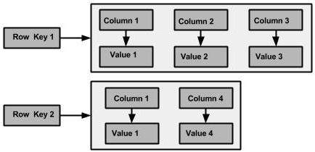

Column
A column is the basic data structure of Cassandra with three values, namely key or column name, value, and a time stamp. Given below is the structure of a column.
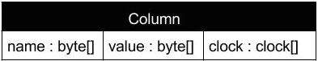

Cassandra query language

Starting cqlsh
Start cqlsh using the command cqlsh as shown below. It gives the Cassandra cqlsh prompt as output.
[hadoop@linux bin]$ cqlsh
Connected to Test Cluster at 127.0.0.1:9042.
[cqlsh 5.0.1 | Cassandra 2.1.2 | CQL spec 3.2.0 | Native protocol v3]
Use HELP for help.
cqlsh>
cqlsh commands
Options | Usage
cqlsh --help | Shows help topics about the options of cqlsh commands.
cqlsh --version | Provides the version of the cqlsh you are using.
cqlsh --color | Directs the shell to use colored output.
cqlsh --debug | Shows additional debugging information.
cqlsh --execute  cql_statement | Directs the shell to accept and execute a CQL command.
cqlsh --file= “file name” | If you use this option, Cassandra executes the command in the given file and exits.
cqlsh --no-color | Directs Cassandra not to use colored output.
cqlsh -u “user name” | Using this option, you can authenticate a user. The default user name is: cassandra.
cqlsh-p “pass word” | Using this option, you can authenticate a user with a password. The default password is: cassandra.

CQL Data Definition Commands
- CREATE KEYSPACE - Creates a KeySpace in Cassandra.
- USE - Connects to a created KeySpace.
- ALTER KEYSPACE - Changes the properties of a KeySpace.
- DROP KEYSPACE - Removes a KeySpace
- CREATE TABLE - Creates a table in a KeySpace.
- ALTER TABLE - Modifies the column properties of a table.
- DROP TABLE - Removes a table.
- TRUNCATE - Removes all the data from a table.
- CREATE INDEX - Defines a new index on a single column of a table.
- DROP INDEX - Deletes a named index.

CQL Data Manipulation Commands
- INSERT - Adds columns for a row in a table.
- UPDATE - Updates a column of a row.
- DELETE - Deletes data from a table.
- BATCH - Executes multiple DML statements at once.

CQL Clauses
- SELECT - This clause reads data from a table
- WHERE - The where clause is used along with select to read a specific data.
- ORDERBY - The orderby clause is used along with select to read a specific data in a specific order.

Queries
1.cqlsh> help

Documented shell commands:
===========================
CAPTURE CLS COPY DESCRIBE EXPAND LOGIN SERIAL SOURCE UNICODE
CLEAR CONSISTENCY DESC EXIT HELP PAGING SHOW TRACING

CQL help topics:
================
AGGREGATES CREATE_COLUMNFAMILY DROP_INDEX LIST_PERMISSIONS UUID
ALTER_KEYSPACE CREATE_FUNCTION DROP_KEYSPACE LIST_USERS
ALTER_TABLE CREATE_INDEX DROP_TABLE PERMISSIONS
ALTER_TYPE CREATE_KEYSPACE DROP_TRIGGER REVOKE
ALTER_USER CREATE_TABLE DROP_TYPE SELECT
APPLY CREATE_TRIGGER DROP_USER SELECT_JSON
ASCII CREATE_TYPE FUNCTIONS TEXT
BATCH CREATE_USER GRANT TIME
BEGIN DATE INSERT TIMESTAMP
BLOB DELETE INSERT_JSON TRUNCATE
BOOLEAN DROP_AGGREGATE INT TYPES
COUNTER DROP_COLUMNFAMILY JSON UPDATE
CREATE_AGGREGATE DROP_FUNCTION KEYWORDS USE
2. cqlsh> describe cluster;
Cluster: Test Cluster
Partitioner: Murmur3Partitioner

3. cqlsh> describe keyspaces;

system_traces system_auth system system_distributed

4.cqlsh> describe tables;
Keyspace system_traces
----------------------
events sessions

Keyspace system_auth
--------------------
resource_role_permissons_index role_permissions role_members roles

Keyspace system
---------------
available_ranges size_estimates schema_usertypes compactions_in_progress
range_xfers peers paxos schema_aggregates
schema_keyspaces schema_triggers batchlog schema_columnfamilies
schema_columns sstable_activity schema_functions local
"IndexInfo" peer_events compaction_history hints

Keyspace system_distributed
---------------------------
repair_history parent_repair_history

KEYSPACE creation
1. cqlsh> CREATE KEYSPACE Students WITH REPLICATION = {
... 'class':'SimpleStrategy', 'replication_factor':1 };

2. Describing the keyspace
cqlsh> DESCRIBE students;
CREATE KEYSPACE students WITH replication = {'class': 'SimpleStrategy', 'replication_factor': '1'} AND durable_writes = true;
3. Getting details of existing keyspaces
cqlsh> SELECT * FROM system.schema_keyspaces;

keyspace_name | durable_writes | strategy_class | strategy_options
--------------------+----------------+---------------------------------------------+----------------------------
system_auth | True | org.apache.cassandra.locator.SimpleStrategy | {"replication_factor":"1"}
system_distributed | True | org.apache.cassandra.locator.SimpleStrategy | {"replication_factor":"3"}
system | True | org.apache.cassandra.locator.LocalStrategy | {}
system_traces | True | org.apache.cassandra.locator.SimpleStrategy | {"replication_factor":"2"}
students | True | org.apache.cassandra.locator.SimpleStrategy | {"replication_factor":"1"}

(5 rows)

4. TO USE THE KEYSPACE
cqlsh> use students;
cqlsh:students>

5.To know /Set the consistency level
cqlsh:students> consistency;
Current consistency level is ONE.
6.SHOW – to get cassandra version, Data type and host
cqlsh> show version;
[cqlsh 5.0.1 | Cassandra 2.2.8 | CQL spec 3.3.1 | Native protocol v4]
cqlsh> show host;
Connected to Test Cluster at 127.0.0.1:9042.

To alter Keyspace with properties
cqlsh> alter keyspace students with replication = {'class':'SimpleStrategy','replication_factor':2};

To drop Keyspace
cqlsh> Drop keyspace keyspacename;

7. TO CREATE COLUMN FAMILY
1. cqlsh:students> create table studentinfo(RNO int Primary KEY,SNAME text,DOJ timestamp,CGPA float);
2. To describe tables
cqlsh:students> describe tables;
studentinfo (only one table inside the kkeyspace students)
3. To describe the existing tables
cqlsh> describe tables;
Keyspace students
-----------------
studentinfo

Keyspace system_traces
----------------------
events sessions

Keyspace system_auth
--------------------
resource_role_permissons_index role_permissions role_members roles

Keyspace system
---------------
available_ranges size_estimates schema_usertypes compactions_in_progress
range_xfers peers paxos schema_aggregates
schema_keyspaces schema_triggers batchlog schema_columnfamilies
schema_columns sstable_activity schema_functions local
"IndexInfo" peer_events compaction_history hints

Keyspace system_distributed
---------------------------
repair_history parent_repair_history
4. To describe the table studentinfo
cqlsh:students> describe studentinfo;
CREATE TABLE students.studentinfo (
rno int PRIMARY KEY,
cgpa float,
doj timestamp,
sname text
) WITH bloom_filter_fp_chance = 0.01
AND caching = '{"keys":"ALL", "rows_per_partition":"NONE"}'
AND comment = ''
AND compaction = {'class': 'org.apache.cassandra.db.compaction.SizeTieredCompactionStrategy'}
AND compression = {'sstable_compression': 'org.apache.cassandra.io.compress.LZ4Compressor'}
AND dclocal_read_repair_chance = 0.1
AND default_time_to_live = 0
AND gc_grace_seconds = 864000
AND max_index_interval = 2048
AND memtable_flush_period_in_ms = 0
AND min_index_interval = 128
AND read_repair_chance = 0.0
AND speculative_retry = '99.0PERCENTILE';

CRUD OPERATIONS
1.To insert data into column family
An insert writes onre or more columns to arecord in cassandra table automatically.
Insert statement does not return vlaues.
BEGIN BATCH
... Insert into studentinfo(RNO,SNAME,DOJ,CGPA) Values(1,'Arvind','2012-05-24',9.8)
Insert into studentinfo(RNO,SNAME,DOJ,CGPA) Values(2,'Giri','2013-03-20',8.5)
Insert into studentinfo(RNO,SNAME,DOJ,CGPA) Values(3,'Dharsan','2015-09-04',8.0)
Insert into studentinfo(RNO,SNAME,DOJ,CGPA) Values(4,'Tharun','2010-04-20',7.5)
APPLY BATCH;

2. To display Table
cqlsh:students> select*from studentinfo;
rno | cgpa | doj | sname
-----+------+--------------------------+----------
1 | 9.8 | 2012-05-23 18:30:00+0000 | Arvind
2 | 8.5 | 2013-03-19 18:30:00+0000 | Giri
4 | 7.5 | 2016-02-03 18:30:00+0000 | Tharun
3 | 7.8 | 2015-04-19 18:30:00+0000 | Dharshan
(4 rows)
3. Where condition
cqlsh:students> select *from studentinfo where RNO=2;
rno | cgpa | doj | sname
-----+------+--------------------------+-------
2 | 8.5 | 2013-03-19 18:30:00+0000 | Giri

(1 rows)
cqlsh:students> Select *from studentinfo WHERE RNO IN(1,3);
rno | cgpa | doj | phone | sname
-----+------+--------------------------+-------+----------
1 | 9.8 | 2012-05-23 18:30:00+0000 | null | Arvind
3 | 7.8 | 2015-04-19 18:30:00+0000 | null | Dharshan

(2 rows)
4.Alter table:
Adding new column
alter table studentinfo ADD phone int;
5.Update table
- An update updates one or more column values for a given row to the cassandra table. It does not return anything.
- Update is not possible Primary key filed;
> UPDATE studentinfo SET phone=99 where RNO=1;
cqlsh:students> update studentinfo SET rno=5 where rno=4;
InvalidRequest: Error from server: code=2200 [Invalid query] message="PRIMARY KEY part rno found in SET part"

Creating Index
We can create index for the column not mentioned as PK.
1. To create index for the column sname:
cqlsh:students> Create INDEX ON studentinfo(SNAME);

2. To execute query using index
select * from studentinfo where SNAME='Dharshan';

rno | cgpa | doj | phone | sname
-----+------+--------------------------+-------+----------
3 | 7.8 | 2015-04-19 18:30:00+0000 | 59 | Dharshan

3. To Limit the number of rows:
cqlsh:students> select *from studentinfo LIMIT 2;

rno | cgpa | doj | phone | sname
-----+------+--------------------------+-------+--------
1 | 9.8 | 2012-05-23 18:30:00+0000 | 99 | Arvind
2 | 8.5 | 2013-03-19 18:30:00+0000 | 49 | Giri

4. Delete operation
cqlsh> Delete phone from studentinfo Where RNO=2;
Compound primary key
1. cqlsh:students> Create table projectdetails(pid int,pname text,sname text,rating double,duration int,PRIMARY KEY(pid,pname));
2. To insert values
cqlsh:students> BEGIN BATCH
Insert into projectdetails(pid,pname,sname,rating,duration) values(1,'MS data migiration','arvind',4.5,720)
Insert into projectdetails(pid,pname,sname,rating,duration) values(2,'Data mining','Giri',3.5,800)
Insert into projectdetails(pid,pname,sname,duration,rating)values(5,'Instrumention design','Tharun',750,4.8)
Insert into projectdetails(pid,pname,sname,duration,rating)values(3,'Business analysis','Brindha',850,4.0)
Insert into projectdetails(pid,pname,sname,duration,rating)values(4,'Data science','Chitra',850,5.0)
APPLY BATCH;
3. To display
cqlsh:students> Select *from projectdetails;
pid | pname | duration | rating | sname
-----+----------------------+----------+--------+---------
5 | Instrumention design | 750 | 4.8 | Tharun
1 | MS data migiration | 720 | 4.5 | arvind
2 | Data mining | 800 | 3.5 | Giri
4 | Data science | 850 | 5 | Chitra
3 | Business analysis | 850 | 4 | Brindha
(5 rows)
ALLOW FILTERING
when one attempts potentially expensive query that might involve seraching a range of rows. Aprompt such as the one shown below apperas:
Bad Request: Cannot execute this query as it might involve data filtering and thus may have unpredictable performance. If you want to execute this query despite the performance unpredictability, use ALLOW FILTERING.
- Cassandra knows that it might not be able to execute the query in an efficient way.
- It is therefore warning you: “Be careful. Executing this query as such might not be a good idea as it can use a lot of your computing resources”.
- The only way Cassandra can execute this query is by retrieving all the rows from the table blogs and then by filtering out the ones which do not have the requested value for the time1 column.

cqlsh:students> select *from projectdetails where pname='Data mining'ALLOW FILTERING;
pid | pname | duration | rating | sname
-----+-------------+----------+--------+-------
2 | Data mining | 800 | 3.5 | Giri

ORDER BY
- Cassandra to store the clustering key in order when the data is written to the SSTables.
- Order by clause can select a single column only
- This column is the second column of the compound Pks.
- When using this clause use only column name not alias.
- Default sorting is “ASC”.
- Odrder y will work only with PK with clustering. It needs either IN or EQ operators
- Oder by will work only when you trun off PAGING
Paging provides the output of queries in 100-line chunks followed by the more prompt. To get the next chunk, press the space bar. Turning paging on enables query paging for all further queries. Using no ON or OFF argument with the command shows the current query paging status.

Create a new table projectdetails with clustering.
cqlsh:students> Create table projectdetails1(pid int,pname text,sname text,rating double,duration int,PRIMARY KEY(pid,pname)) WITH CLUSTERING ORDER BY(pname DESC);
To insert values
BEGIN BATCH
Insert into projectdetails1(pid,pname,sname,rating,duration) values(1,'MS data migiration','arvind',4.5,720)
Insert into projectdetails1(pid,pname,sname,rating,duration) values(2,'Data mining','Giri',3.5,800)
Insert into projectdetails1(pid,pname,sname,duration,rating)values(5,'Instrumention design','Tharun',750,4.8)
Insert into projectdetails1(pid,pname,sname,duration,rating)values(3,'Business analysis','Brindha',850,4.0)
Insert into projectdetails1(pid,pname,sname,duration,rating)values(4,'Data science','Chitra',850,5.0)
APPLY BATCH;
Turn off paging
cqlsh:students> paging off;
Disabled Query paging.
cqlsh:students> select *from projectdetails1 where pid IN(1,5) order by pname DESC;

pid | pname | duration | rating | sname
-----+----------------------+----------+--------+--------
1 | MS data migiration | 720 | 4.5 | arvind
5 | Instrumention design | 750 | 4.8 | Tharun
(2 rows)

Aggereagte Function
1. Finding Max
select pid,max(rating) from projectdetails1;
pid | system.max(rating)
-----+--------------------
5 | 5
2. using Count
cqlsh:students> select Count(pid) from projectdetails1;
system.count(pid)
-------------------
5
3. Sum
select sum(rating) from projectdetails1;
system.sum(rating)
--------------------
21.8

(1 rows)
NOTE:
Warnings :
Aggregation query used without partition key

The Partition Key is responsible for data distribution across your nodes. Cassandra uses the first column name as the partition key.
- The Clustering Key is responsible for data sorting within the partition.
- The Primary Key is equivalent to the Partition Key in a single-field-key table.
- The Composite/Compound Key is just a multiple-columns key

Collections
Syntax for collection
ALTER TABLE TABLE NAME ADD COLLECTION TYPE <DATA TYPE>

Set collection
A column of type set consists of unordered unique values. When the column is required ,it returns the values in sorted order.
Example:
Consider the table studentinfo.
select *from studentinfo;
rno | cgpa | doj | phone | sname
-----+------+--------------------------+-------+----------
1 | 9.8 | 2012-05-23 18:30:00+0000 | 99 | Arvind
2 | 8.5 | 2013-03-19 18:30:00+0000 | 49 | Giri
4 | 7.5 | 2016-02-03 18:30:00+0000 | 79 | Tharun
3 | 7.8 | 2015-04-19 18:30:00+0000 | 59 | Dharshan

Now we will try to add one column “Hobbies” which is Set type.
cqlsh:students> Alter Table studentinfo ADD Hobbies set<text>;
To confirm the strucutre of the table
cqlsh:students> describe table studentinfo;
CREATE TABLE students.studentinfo (
rno int PRIMARY KEY,
cgpa float,
doj timestamp,
hobbies set<text>,
phone int,
sname text
) WITH bloom_filter_fp_chance = 0.01
AND caching = '{"keys":"ALL", "rows_per_partition":"NONE"}'
AND comment = ''
AND compaction = {'class': 'org.apache.cassandra.db.compaction.SizeTieredCompactionStrategy'}
AND compression = {'sstable_compression': 'org.apache.cassandra.io.compress.LZ4Compressor'}
AND dclocal_read_repair_chance = 0.1
AND default_time_to_live = 0
AND gc_grace_seconds = 864000
AND max_index_interval = 2048
AND memtable_flush_period_in_ms = 0
AND min_index_interval = 128
AND read_repair_chance = 0.0
AND speculative_retry = '99.0PERCENTILE';
CREATE INDEX studentinfo_sname_idx ON students.studentinfo (sname);

To insert values for the new columns
UPDATE studentinfo SET Hobbies = Hobbies +{'chess,Tennis'} where rno=1;
UPDATE studentinfo SET Hobbies = Hobbies +{'Cricket,TableTennis'} where rno=2;
UPDATE studentinfo SET Hobbies = Hobbies +{'singing,Reading'} where rno=3;
UPDATE studentinfo SET Hobbies = Hobbies +{'Cricket,Tennis'} where rno=4;

cqlsh:students> select*from studentinfo;

rno | cgpa | doj | hobbies | phone | sname
-----+------+--------------------------+-------------------------+-------+----------
1 | 9.8 | 2012-05-23 18:30:00+0000 | {'chess,Tennis'} | 99 | Arvind
2 | 8.5 | 2013-03-19 18:30:00+0000 | {'Cricket,TableTennis'} | 49 | Giri
4 | 7.5 | 2016-02-03 18:30:00+0000 | {'Cricket,Tennis'} | 79 | Tharun
3 | 7.8 | 2015-04-19 18:30:00+0000 | {'singing,Reading'} | 59 | Dharshan

List:
when the order of elements required we can use list.
A list also allows to store the same value multiple times.

cqlsh:students> alter table studentinfo ADD language list<text>;
To insert values:
UPDATE studentinfo SET language = language + ['Hindi, English'] where rno=1;
UPDATE studentinfo SET language = language + ['Tamil, English'] where rno=2;
UPDATE studentinfo SET language = language + ['Hindi, Telgu'] where rno=3;
UPDATE studentinfo SET language = language + ['English, Sanskrit'] where rno=4;

More practice on SET and LIST
To create a table “users “ with an “emails Column. Email is set type.
1. Table creation:
Create Table users(uid text Primary Key,FName text,LName text,emails set<text>);
2.Inserting values (single insertion)
Insert into users(uid,Fname,Lname,emails) Values('AB','Albert','Baggins',{'ab@baggins.com,ab@gmail.com'});

cqlsh:students> Select *from users;

uid | emails | fname | lname
-----+---------------------------------+--------+---------
AB | {'ab@baggins.com,ab@gmail.com'} | Albert | Baggins
3.Adding an element to set using the update command and addition (+) operator
UPDATE users SET emails = emails + {'ab@friendssofmordor.org'} where uid='AB';
cqlsh:students> Select *from users;

uid | emails | fname | lname
-----+------------------------------------------------------------+--------+---------
AB | {'ab@baggins.com,ab@gmail.com', 'ab@friendssofmordor.org'} | Albert | Baggins

4. To retrieve email address for albert
Select uid,emails from user where uid='AB';

cqlsh:students> Select uid,emails from users where uid='AB';

uid | emails
-----+------------------------------------------------------------
AB | {'ab@baggins.com,ab@gmail.com', 'ab@friendssofmordor.org'}

5. To remove an element from s set using the subtraction(-) opeartor
UPDATE users SET emails = emails -{'ab@friendsofmordor.org'} Where uid='AB';

6. To remove all elements from a set uisng UPDATE or DELETE
UPDATE users SET emails ={} where uid ='AB';
or
DELETE emails FROM users where uid ='AB';
cqlsh:students> select*from users;

uid | emails | fname | lname
-----+--------+--------+---------
AB | null | Albert | Baggins
7. To alter the table users to add column topplaces of type “list”
ALTER Table users ADD topplaces list<text>;
8. To update list column
Update users SET topplaces = ['Lonavla','Khandala'] where uid ='AB';
cqlsh:students> select *from users;

uid | emails | fname | lname | topplaces
-----+--------+--------+---------+-------------------------
AB | null | Albert | Baggins | ['Lonavla', 'Khandala']
9. Prepand an element to the list by enclosing it in square barckets and using the addition (+) operator
Update users SET topplaces = ['Mahabaleshwar'] + topplaces where uid ='AB';
cqlsh:students> select*from users;

uid | emails | fname | lname | topplaces
-----+--------+--------+---------+------------------------------------------
AB | null | Albert | Baggins | ['Mahabaleshwar', 'Lonavla', 'Khandala']
10. To append an element to the list
Update users SET topplaces =topplaces + ['Tapola'] where uid ='AB';
cqlsh:students> select*from users;

uid | emails | fname | lname | topplaces
-----+--------+--------+---------+----------------------------------------------------
AB | null | Albert | Baggins | ['Mahabaleshwar', 'Lonavla', 'Khandala', 'Tapola']
11. To query the database for the list type
Select uid,topplaces from users where uid='AB';
cqlsh:students> Select uid,topplaces from users where uid='AB';
uid | topplaces
-----+----------------------------------------------------
AB | ['Mahabaleshwar', 'Lonavla', 'Khandala', 'Tapola']

12. To remove an element from a list using DELETE and the list index position
DELETE topplaces[3] FROM users where uid ='AB';
cqlsh:students> select*from users;
uid | emails | fname | lname | topplaces
-----+--------+--------+---------+------------------------------------------
AB | null | Albert | Baggins | ['Mahabaleshwar', 'Lonavla', 'Khandala']
USING MAP :KEY,VALUE PAIR
- Map is used to map one thing to another.
- A map is a pair of typed values.It is used to store timestamp realted information.
- Each element of the map is stored as a Cassandra column.
- Each element can be individulay quried,modified and dleted.

1. To alter the table users to add a map column “todo”
Alter Table users ADD todo map<timestamp,text>;

2.To isert or update value in users
Update users SET todo = {'2016-11-22':'Cassandra session', '2016-11-22':'Machine leraning'} where uid='AB';
cqlsh:students> select *from users;
uid | emails | fname | lname | todo | topplaces
-----+--------+--------+---------+--------------------------------------------------+------------------------------------------
AB | null | Albert | Baggins | {'2016-11-21 18:30:00+0000': 'Machine leraning'} | ['Mahabaleshwar', 'Lonavla', 'Khandala']
3. To delete an map element
DELETE todo['2016-11-22'] from users where uid ='AB';
cqlsh:students> select*from users;

uid | emails | fname | lname | todo | topplaces
-----+--------+--------+---------+------+------------------------------------------
AB | null | Albert | Baggins | null | ['Mahabaleshwar', 'Lonavla', 'Khandala']

Using COUNTER
A counter is a special column that is changed in increments.
For exmaple we may need a counter column to count the number of times a particular book is isssued from the library by the student.
1. Table creation
Create Table librarybook(cvalue counter,bname varchar,sname varchar,Primary key(bname,sname));
2. Load data in to column counter
UPDATE librarybook SET cvalue = cvalue + 1 Where bname='business analysis' AND sname='giri';
3. Look at the counter value
cqlsh:students> Select *from librarybook;

bname | sname | cvalue
-------------------+-------+--------
business analysis | giri | 1
4. Increase the counter value
UPDATE librarybook SET cvalue = cvalue + 1 Where bname='business analysis' AND sname='Tharun';
cqlsh:students> Select *from librarybook;
bname | sname | cvalue
-------------------+--------+--------
business analysis | Tharun | 1
business analysis | giri | 1

4. Update another record
UPDATE librarybook SET cvalue = cvalue + 1 Where bname='business analysis' AND sname='giri';
cqlsh:students> Select *from librarybook;
bname | sname | cvalue
-------------------+--------+--------
business analysis | Tharun | 1
business analysis | giri | 2

TIME TO LIVE(TTL)
- Data in a clumn, other than a counter column, can have an optional expiration period called TTL.
- The client request may specify a TTL value for the data.
- TTL is specified in seconds

1. Create Table userlogin(uid int Primary Key,pwd text);
2. Insert into userlogin(uid,pwd) values(1,'infy') using TTL 30;
3.cqlsh:students> Select TTL(pwd) From userlogin where uid=1;
ttl(pwd)
----------
3
(1 rows)
cqlsh:students> Select TTL(pwd) From userlogin where uid=1;

ttl(pwd)
----------
ALTER COMMANDS
1. Create Table sample(sid text,sname text,Primary Key(sid));
2. Insert into sample(sid,sname) Values('S101','Big Data');
3. Select * from sample;
sid | sname
------+----------
S101 | Big Data
Alter table to change the data type of column
4. Alter Table sample ALTER sname TYPE varchar;

Text is just an alias for varchar!

Renaming a column
The main purpose of RENAME is to change the names of CQL-generated primary key and column names that are missing from a legacy table. The following restrictions apply to the RENAME operation:
- You can only rename clustering columns, which are part of the primary key.
- You cannot rename the partition key.
- You can index a renamed column.
- You cannot rename a column if an index has been created on it.
- You cannot rename a static column (since you cannot use a static column in the table's primary key).

Modifying table properties
To change the table storage properties set when the table was created, use one of the following formats:
- Use ALTER TABLE and a WITH instruction that introduces the property name and value
- Use ALTER TABLE WITH and a property map, as shown in the next section on compression and compaction.
This example uses the WITH instruction to modify the read_repair_chance property, which configures read repair for tables that use for a non-quorum consistency.
This example also shows how to change multiple properties using AND:
Alter table sample WITH comment = 'Created by subathra' AND read_repair_chance=0.2;

cqlsh:students> Describe table sample;
CREATE TABLE students.sample (
sid text PRIMARY KEY,
sname text
) WITH bloom_filter_fp_chance = 0.01
AND caching = '{"keys":"ALL", "rows_per_partition":"NONE"}'
AND comment = 'Created by subathra'
AND compaction = {'class': 'org.apache.cassandra.db.compaction.SizeTieredCompactionStrategy'}
AND compression = {'sstable_compression': 'org.apache.cassandra.io.compress.LZ4Compressor'}
AND dclocal_read_repair_chance = 0.1
AND default_time_to_live = 0
AND gc_grace_seconds = 864000
AND max_index_interval = 2048
AND memtable_flush_period_in_ms = 0
AND min_index_interval = 128
AND read_repair_chance = 0.2
AND speculative_retry = '99.0PERCENTILE';

DROPING /DELETING
1. Drop a table
DROP Columnfamily TABLE NAME;
> Drop Coumnfamily sample;
2. Drop a Database
DROP Keysapce NAME;
> DROP Keysapce students;
3. To delete a column from table
>Alter table sample DROP sid;

IMPORT AND EXPORT
EXPORT TO CSV
1. Export the content of the table projectdetails in students keyspace to a CSV file.

1. cqlsh:students> select *from projectdetails;

pid | pname | duration | rating | sname
-----+----------------------+----------+--------+---------
5 | Instrumention design | 750 | 4.8 | Tharun
1 | MS data migiration | 720 | 4.5 | arvind
2 | Data mining | 800 | 3.5 | Giri
4 | Data science | 850 | 5 | Chitra
3 | Business analysis | 850 | 4 | Brindha

2. Execute the following command in CQLSH prompt
cqlsh:students> COPY projectdetails(pid,pname,sname,duration,rating) TO '\home\mtech\Desktop\projectdetails1.csv';
Using 1 child processes
Starting copy of students.projectdetails with columns [pid, pname, sname, duration, rating].
Processed: 5 rows; Rate: 13 rows/s; Avg. rate: 12 rows/s
5 rows exported to 1 files in 0.408 seconds.
3. Now you can go to the location home\mtech\Desktop\ you can see the file
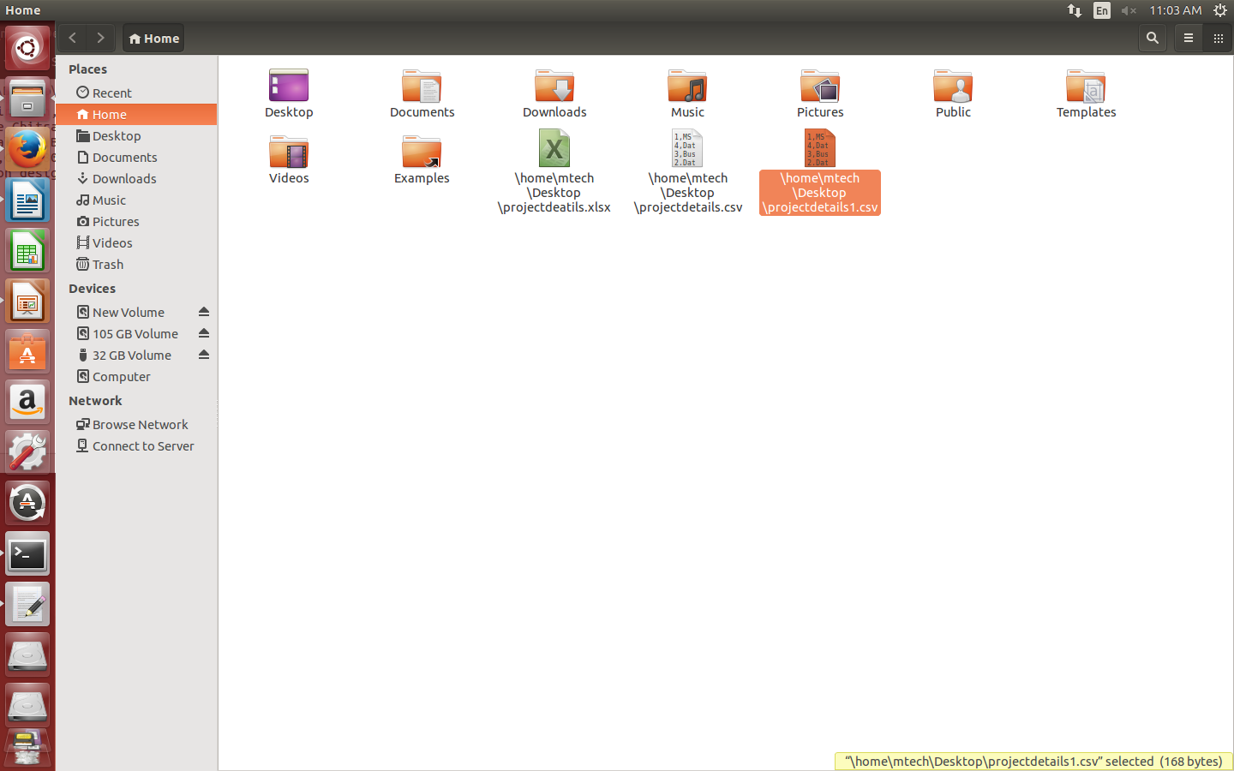
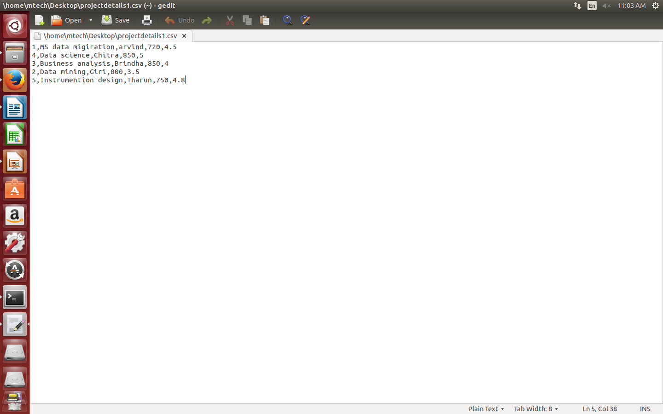
IMPORT from CSV
1. To import data from home\mtech\Desktop\projectdetails1.csv into the table projectdeatils present in the keyspace students;

2. Projectdetails is alredy present in the database. So using TRUNCATE just deleting the content and retaining the schema.
cqlsh:students> TRUNCATE projectdetails;
cqlsh:students> select *from projectdetails;

pid | pname | duration | rating | sname
-----+-------+----------+--------+-------

3.
cqlsh:students> COPY projectdetails(pid,pname,sname,duration,rating) FROM 'projectdetails.csv' with DELIMITER = ',' AND HEADER =TRUE;
Using 1 child processes

Starting copy of students.projectdetails with columns [pid, pname, sname, duration, rating].
Processed: 4 rows; Rate: 8 rows/s; Avg. rate: 11 rows/s
4 rows imported from 1 files in 0.353 seconds (0 skipped).

cqlsh:students> select * from projectdetails;

pid | pname | duration | rating | sname
-----+----------------------+----------+--------+---------
5 | Instrumention design | 750 | 4.8 | Tharun
2 | Data mining | 800 | 3.5 | Giri
4 | Data science | 850 | 5 | Chitra
3 | Business analysis | 850 | 4 | Brindha

COPYING FROM STANDARD INPUT DEVICES
Create a table sample1 with the following schema
1.cqlsh:students> select *from sample1;

pid | duration | pname | rating | sname
-----+----------+-------+--------+-------
2.
cqlsh:students> COPY sample1(pid,pname,sname,duration,rating)FROM STDIN;
Using 1 child processes
Starting copy of students.sample1 with columns [pid, pname, sname, duration, rating].
[Use . on a line by itself to end input] You have type the input in the prompt
[copy] 1,"DM","XXX",500,4.0
[copy] 2,"ML","YYY",700,4.8
[copy] .

cqlsh:students> select *from sample1;

pid | duration | pname | rating | sname
-----+----------+-------+--------+-------
1 | 500 | DM | 4 | XXX
2 | 700 | ML | 4.8 | YYY

Querying system tables
1. Select *from system.schema_keyspaces;
keyspace_name | durable_writes | strategy_class | strategy_options
--------------------+----------------+---------------------------------------------+----------------------------
system_auth | True | org.apache.cassandra.locator.SimpleStrategy | {"replication_factor":"1"}
system_distributed | True | org.apache.cassandra.locator.SimpleStrategy | {"replication_factor":"3"}
system | True | org.apache.cassandra.locator.LocalStrategy | {}
system_traces | True | org.apache.cassandra.locator.SimpleStrategy | {"replication_factor":"2"}
students | True | org.apache.cassandra.locator.SimpleStrategy | {"replication_factor":"2"}
2. select *from system.schema_columnfamilies;
keyspace_name | columnfamily_name | bloom_filter_fp_chance | caching | cf_id | comment | compaction_strategy_class | compaction_strategy_options | comparator | compression_parameters | default_time_to_live | default_validator | dropped_columns | gc_grace_seconds | is_dense | key_validator | local_read_repair_chance | max_compaction_threshold | max_index_interval | memtable_flush_period_in_ms | min_compaction_threshold | min_index_interval | read_repair_chance | speculative_retry | subcomparator | type
system_auth | resource_role_permissons_index | 0.01 | {"keys":"ALL", "rows_per_partition":"NONE"} | 5f2fbdad-91f1-3946-bd25-d5da3a5c35ec | index of db roles with permissions granted on a resource | org.apache.cassandra.db.compaction.SizeTieredCompactionStrategy | {} | org.apache.cassandra.db.marshal.CompositeType(org.apache.cassandra.db.marshal.UTF8Type,org.apache.cassandra.db.marshal.UTF8Type) | {"sstable_compression":"org.apache.cassandra.io.compress.LZ4Compressor"} | 0 | org.apache.cassandra.db.marshal.BytesType | null | 7776000 | False | org.apache.cassandra.db.marshal.UTF8Type | 0 | 32 | 2048 | 3600000 | 4 | 128 | 0 | 99.0PERCENTILE | null | Standard
system_auth | role_members | 0.01 | {"keys":"ALL", "rows_per_partition":"NONE"} | 0ecdaa87-f8fb-3e60-88d1-74fb36fe5c0d | role memberships lookup table | org.apache.cassandra.db.compaction.SizeTieredCompactionStrategy | {} | org.apache.cassandra.db.marshal.CompositeType(org.apache.cassandra.db.marshal.UTF8Type,org.apache.cassandra.db.marshal.UTF8Type) | {"sstable_compres

It will display all the column families.

3.Select *from system.schema_columns;
keyspace_name | columnfamily_name | column_name | component_index | index_name | index_options | index_type | type | validator
--------------------+--------------------------------+-------------------------+-----------------+------------+---------------+------------+----------------+-----------------------------------------------------------------------------------------------------------------------------
system_auth | resource_role_permissons_index | resource | null | null | null | null | partition_key | org.apache.cassandra.db.marshal.UTF8Type
system_auth | resource_role_permissons_index | role | 0 | null | null | null | clustering_key | org.apache.cassandra.db.marshal.UTF8Type
system_auth | role_members | member | 0 | null | null | null | clustering_key | org.apache.cassandra.db.marshal.UTF8Type
system_auth | role_members | role | null | null | null | null | partition_key | org.apache.cassandra.db.marshal.UTF8Type
system_auth | role_permissions | permissions | 1 | null | null | null | regular | org.apache.cassandra.db.marshal.SetType(org.apache.cassandra.db.marshal.UTF8Type)
system_auth | role_permissions | resource | 0 | null | null | null | clustering_key | org.apache.cassandra.db.marshal.UTF8Type
system_auth | role_permissions | role | null | null | null | null | partition_key | org.apache.cassandra.db.marshal.UTF8Type
system_auth | roles | can_login | 0 | null | null | null | regular | org.apache.cassandra.db.marshal.BooleanType
system_auth | roles | is_superuser | 0 | null | null | null | regular | org.apache.cassandra.db.marshal.BooleanType
system_auth | roles | member_of | 0 | null | null | null | regular | org.apache.cassandra.db.marshal.SetType(org.apache.cassandra.db.marshal.UTF8Type)
system_auth | roles | role | null | null | null | null | partition_key | org.apache.cassandra.db.marshal.UTF8Type
system_auth | roles | salted_hash | 0 | null | null | null | regular | org.apache.cassandra.db.marshal.UTF8Type
system_distributed | parent_repair_history | columnfamily_names | 0 | null | null | null | regular | org.apache.cassandra.db.marshal.SetType(org.apache.cassandra.db.marshal.UTF8Type)
system_distributed | parent_repair_history | exception_message | 0 | null | null | null | regular | org.apache.cassandra.db.marshal.UTF8Type
system_distributed | parent_repair_history | exception_stacktrace | 0 | null | null | null | regular | org.apache.cassandra.db.marshal.UTF8Type
system_distributed | parent_repair_history | finished_at | 0 | null | null | null | regular | org.apache.cassandra.db.marshal.TimestampType
system_distributed | parent_repair_history | keyspace_name | 0 | null | null | null | regular | org.apache.cassandra.db.marshal.UTF8Type
system_distributed | parent_repair_history | parent_id | null | null | null | null | partition_key | org.apache.cassandra.db.marshal.TimeUUIDType
system_distributed | parent_repair_history | requested_ranges | 0 | null | null | null |

....................................MORE.................................................
4. Select *from system.local;
key | bootstrapped | broadcast_address | cluster_name | cql_version | data_center | gossip_generation | host_id | listen_address | native_protocol_version | partitioner | rack | release_version | rpc_address | schema_version | thrift_version | tokens
local | COMPLETED | 127.0.0.1 | Test Cluster | 3.3.1 | datacenter1 | 1479700255 | 44095510-2e7d-42ad-8764-a1c152b07f48 | 127.0.0.1 | 4 | org.apache.cassandra.dht.Murmur3Partitioner | rack1 | 2.2.8 | 127.0.0.1 | 42c60d4a-0f93-3860-a120-b59cb207b3d2 | 20.1.0 | {'-1065190841651975577', '-1066113856289078448', '-1088768602654042356', '-1123501077258769017', '-1163045290242846239', '-11
5. Select*from system.peers;
peer | data_center | host_id | preferred_ip | rack | release_version | rpc_address | schema_version | tokens

